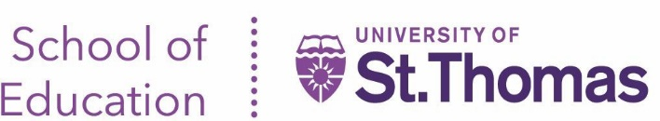

Work-and-Learn:

Special Education License

Work-and-Learn Program aims to recruit, prepare, retain and support highly qualified paraprofessionals and Tier 1 and Tier 2 teachers on their journey to become a Tier 3 licensed teacher. It provides an affordable, accessible, and accelerated program to earn a Minnesota teaching license and master’s degree in 2 years.

WHO SHOULD APPLY?
Individuals who are dedicated to education, are current or prospective employees of one of the partner districts and have a bachelor’s degree from an accredited institution.

WHAT WILL THE PROGRAM LOOK LIKE?
- Participants will be employed as teachers of record or paraprofessionals by school district.
- Participants will take a combination of online and/or face-to-face courses in a cohort model at the University of St. Thomas and district site.
  - One evening a week for a face-to-face class and one evening a week for Online class.
  - No more than two classes at a time with three classes completed per semester (2 - 8 week classes and 1 – 16 week class).
- Cohorts of 18-25 students starting each fall.

Year 1 |  |  |  | Year 2
Fall | J-Term | Spring | Summer |  |  | Fall | J-Term | Spring
- Standards of Effective Practice  - Classroom Engagement  - Effective Teaching and Learning  - Field Experiences | - Educational Equity & Inclusive Practices  - Field Experiences | - Literacy Development  - Fundamental courses in Special Education  - Field Experiences | - Special Education courses |  |  | - Special Education courses  - Clinical Practice | - Disability Specific Method courses  - Clinical Practice | - Clinical Practice (on the job)  - Master’s Research

WHAT DOES THE PROGRAM COST? *
Program | Credits
Initial Academic Behavior Strategist License Coursework | 31 credits
Add on Masters Degree | 3 credits
Add on Autism Spectrum Disorder or Emotional Behavior Disorders License Coursework | 8 credits
- University of St. Thomas tuition for MA degree
- Cost of books is an additional fee and varies by course
- Financial aid available
  - Participants may be eligible for Federal student loan forgiveness while teaching
  - Participants of color may be eligible for Collaborative Urban Educator funding

AFTER 1ST LICENSE
The University of St. Thomas makes it very easy to add on 1 of 6 additional licenses with 2-3 additional courses.

HOW TO BEGIN THE PROCESS
Contact Barbara Jo Stahl - bjstahl@stthomas.edu with your school’s interest.

The University of St. Thomas will work with planning team members to create a Work-and-Learn serving program specific to your district.
District teachers will be recruited to co-teacher Work-and-Learn courses with University of St. Thomas faculty members.

